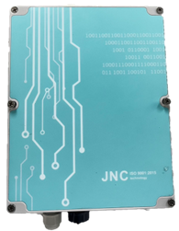
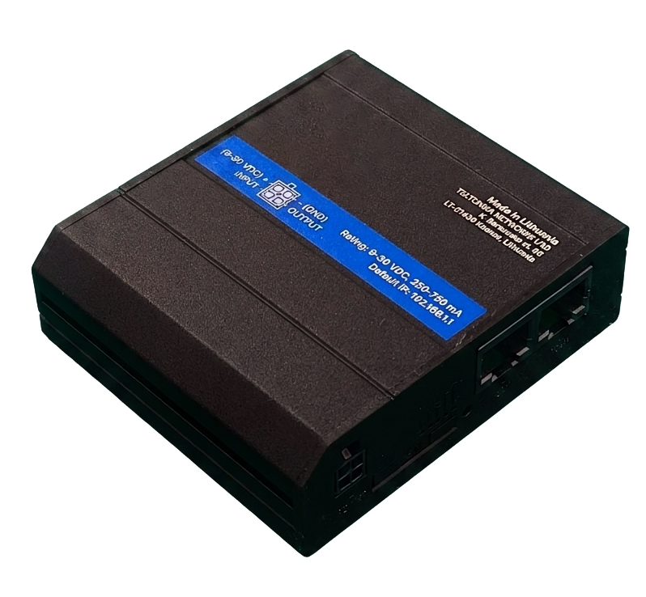
[Features]
Without casing
Includes waterproof case
- Supports 4G LTE, 3G, and 2G; multi-band support ensures stable
global connectivity
- Features an automatic failover mechanism to ensure
continuous communication if the primary connection is interrupted.
- Features a rugged housing and wide-temperature design,
suitable for various harsh industrial environments.
- Built-in digital I/O supports remote device monitoring
and automated control.
- Provides comprehensive security protection and multiple VPN encryption mechanisms to ensure data security.
- Supports cloud-based remote management, significantly improving maintenance efficiency and reducing costs.
- Supports Wi-Fi functionality, serving as a wireless access point for multiple devices to connect.
4GR | ━ | Code 1 | ━ | Code 2
[Optional Code]
Code 1 | Number of ethernet holes | Code 2 | Shell
1 | WAN*1 and LAN*1  can be adjusted to LAN*2 | N | None
4 | 4 LAN | 175 | IP68 waterproof case (PCW175)
4 | 4 LAN | ABS | IP68 waterproof case  300*300*180mm

※If code 1 is 4 LAN, code 2 must be equipped with ABS.
※4G router compatible with unlimited data SIM plans only.
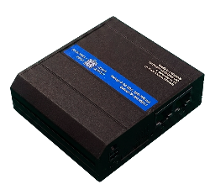
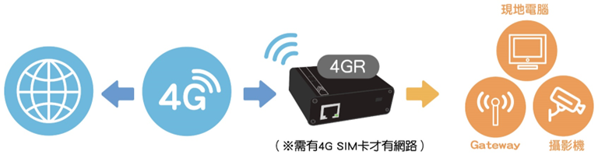
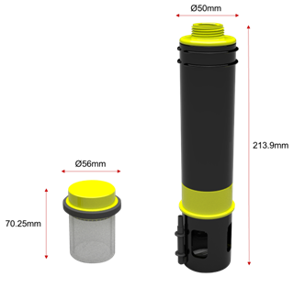
[Wiring Application Diagram]
4GR
(4G SIM card is required for Internet access)
Camera
Computer

[Specifications]
Power supply | 9-30 VDC，Power Consumption <6.5W
LTE Module | Supports 4G/LTE (Cat 4), 3G and 2G networks
Processor and memory | CPU | Mediatek MIPS 24Kc 580MHz
Processor and memory | Memory | 128 MB RAM
Processor and memory | Storage space | 16 MB Flash
Interface and Slots | Ethernet | 2 x 10/100 ports (1 x WAN configurable as LAN, 1 x LAN)
Interface and Slots | SIM 卡 | 1 external SIM card slot
Interface and Slots | Digital I/O | One digit input, one digit output
Wireless Functionality | With WiFi access point and hotspot functionality.
Operating Temperature | -40 °C to 75 °C
Network Protocols | Supports TCP, UDP, IPv4, IPv6, ICMP, DNS, HTTP/HTTPS
Firewall | Protection against DDoS attacks (such as SYN flood) and port scanning

